1. If the scan results include open, closed and filtered ports. This is an indication of man in the middle filtering taking place.
2. Open networks like Starbucks will be more suspectable to filtering than a dedicated internet connection.

In other words, when you use a public Wi-Fi network, your internet activity is more likely to be monitored, filtered, or restricted, whereas a dedicated internet connection is generally more secure and private.

1. nmap 192.168.1.10.*

Asterisks mean that NMAP will scan all the subnets from 1 -255.

SUBNETTING :

192.168.8.0

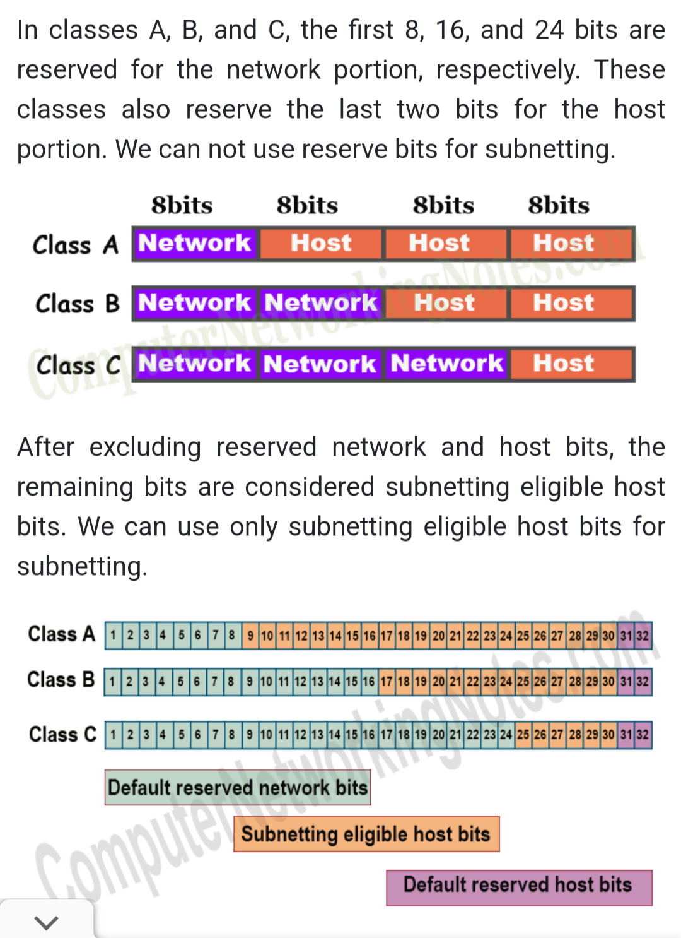

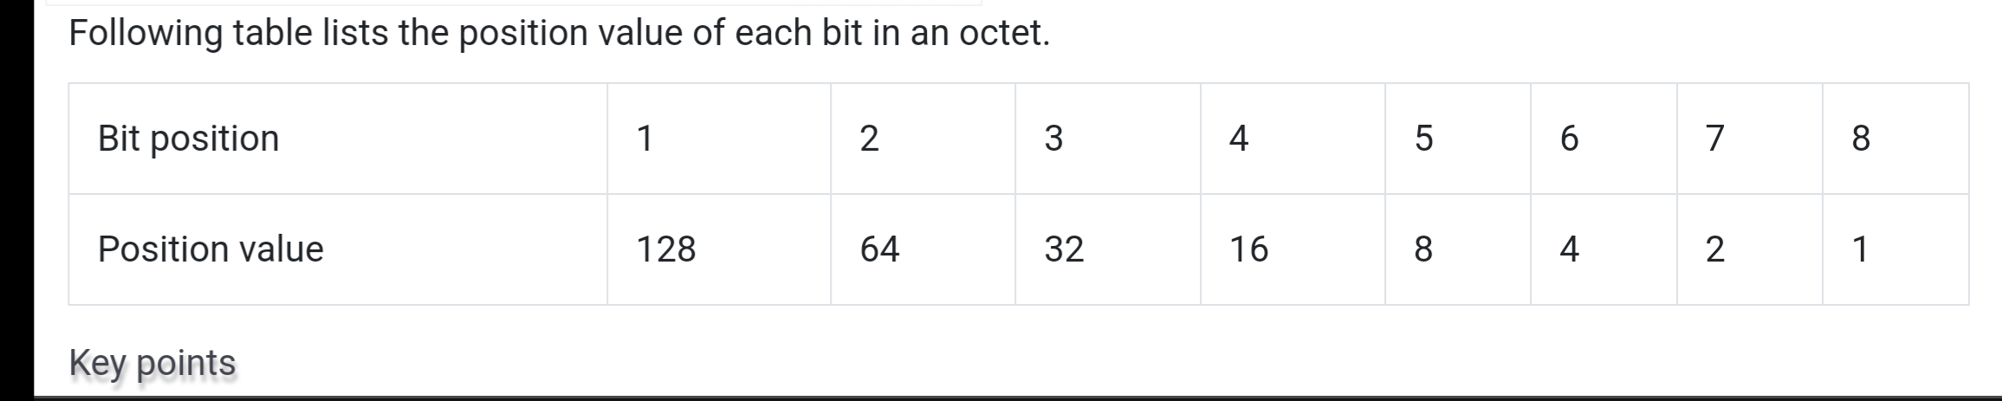

For example 117 in binary will be 01110101

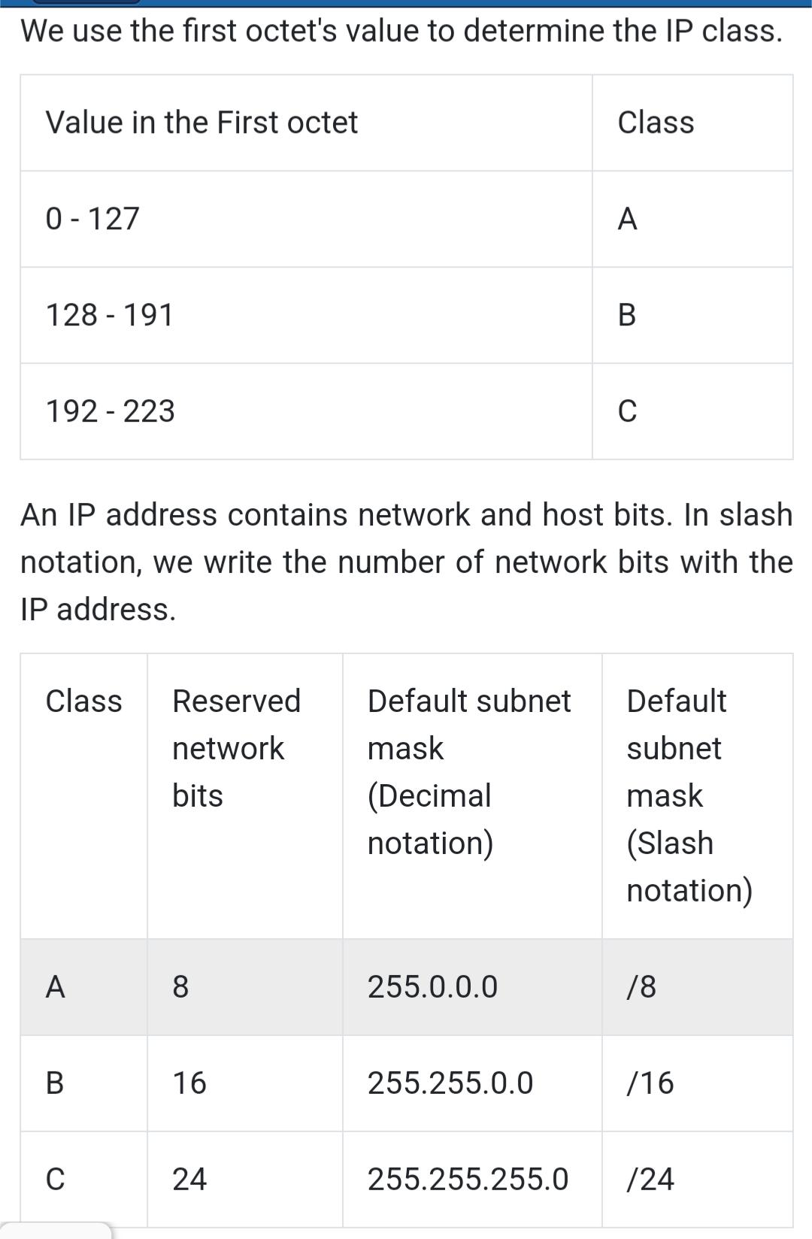

Host bits = 32 - Network bits

Number of host bits used in subnetting =

Total bits used in network portion – Reserved bits for the network portion

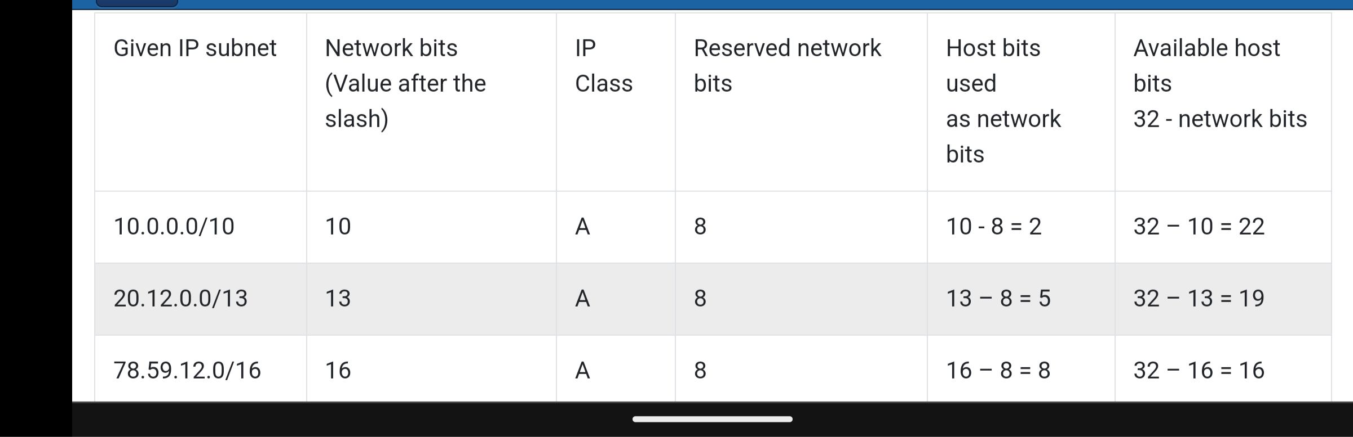

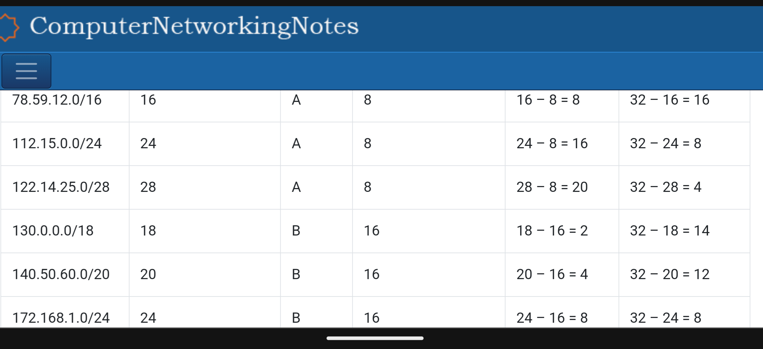

Once we know how many host bits are used as network bits to create additional networks, we can use the following formulas to calculate the number of networks, total hosts, and valid hosts.

Number of networks (subnet) = 2^N

Number of total host addresses in each network = 2^H

Number of valid host addresses in each network = 2^H – 2

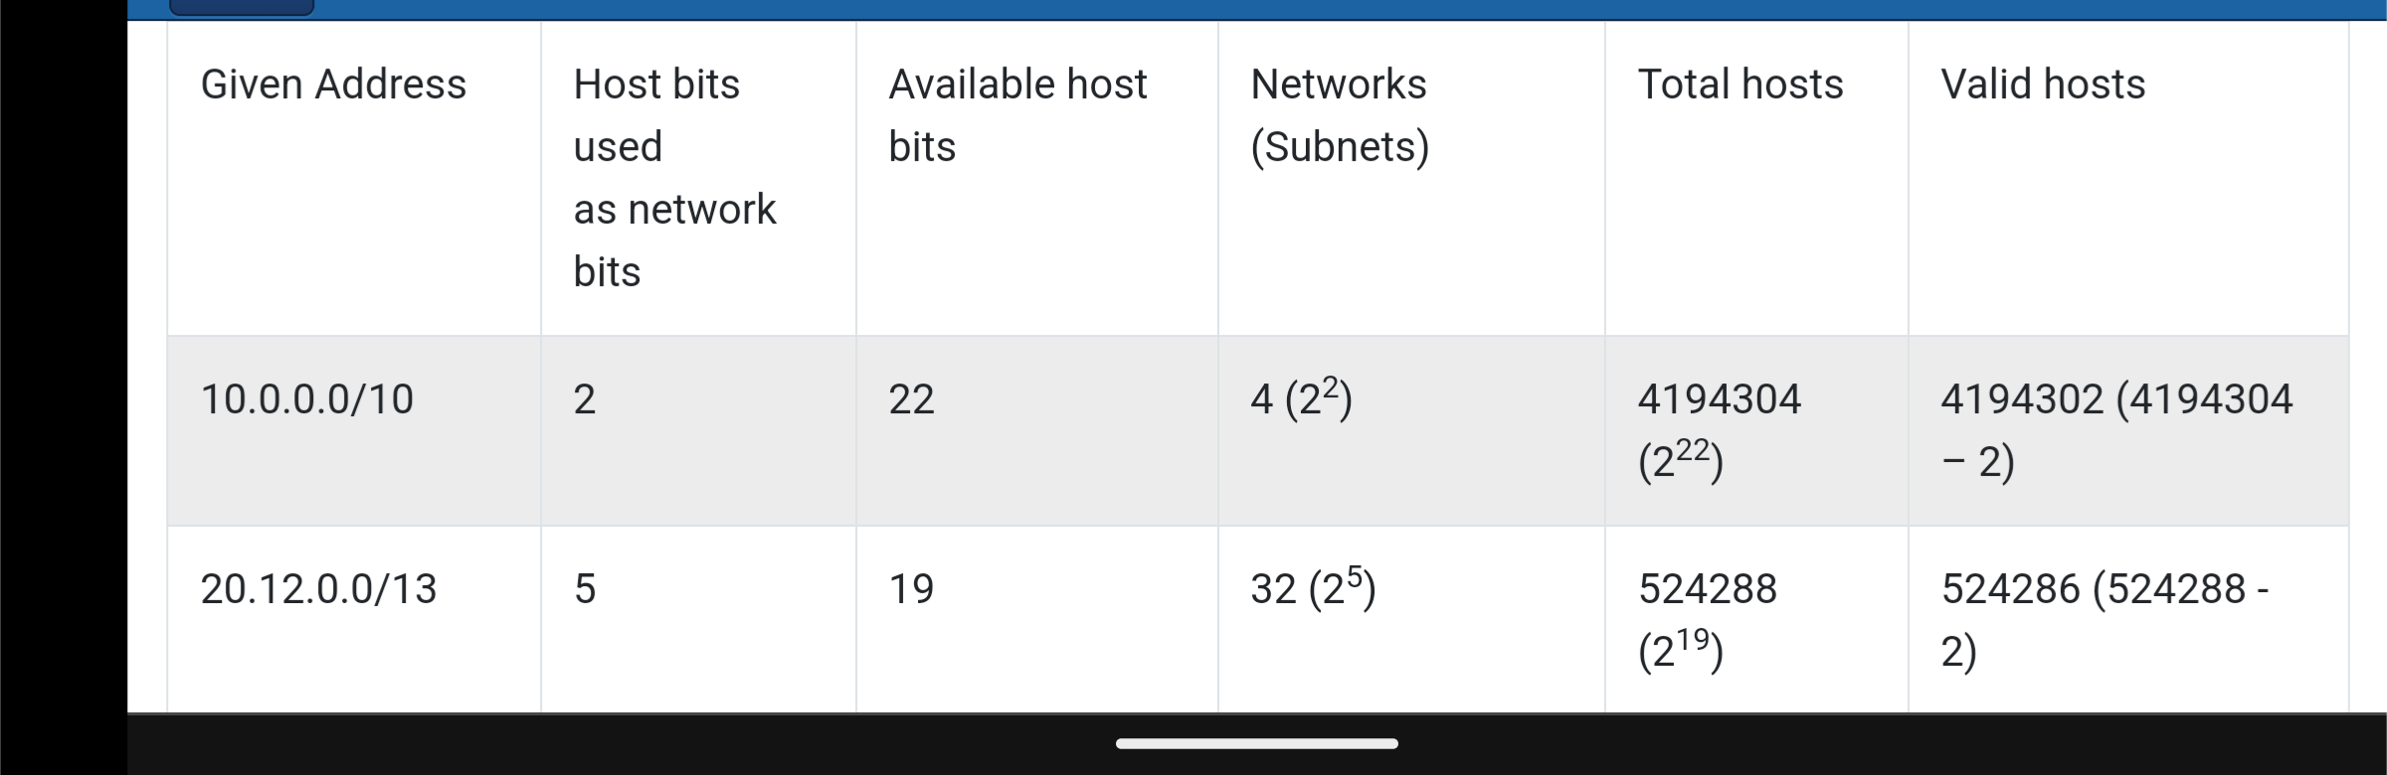

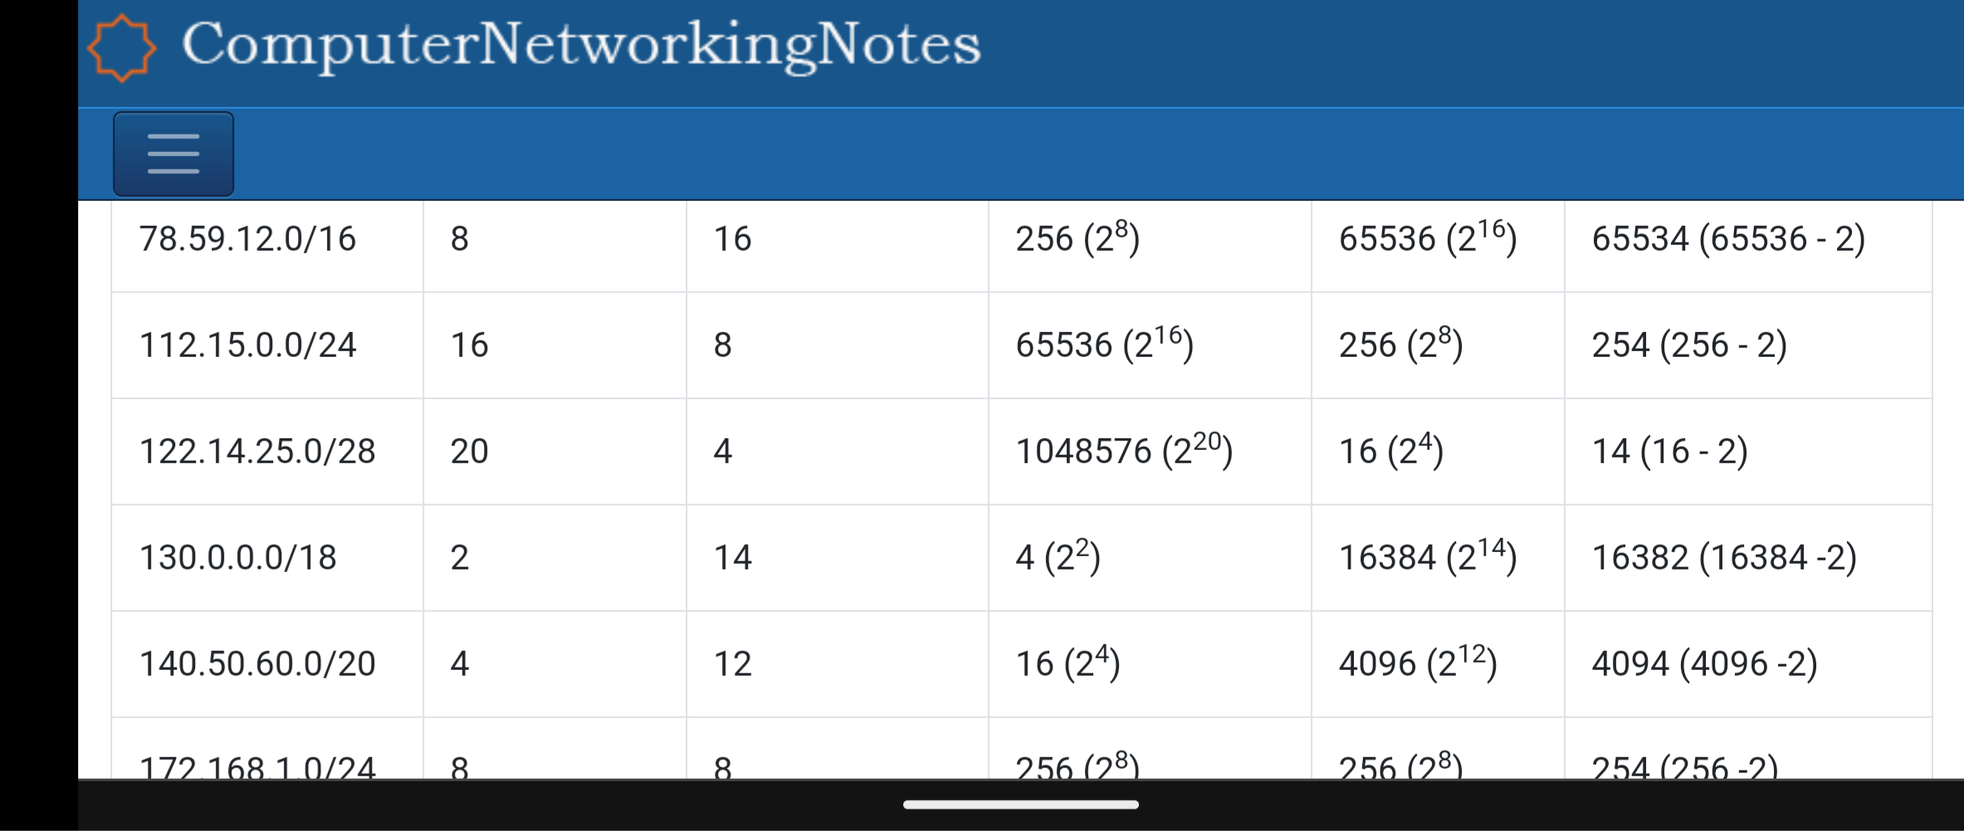

Network address and broadcast address

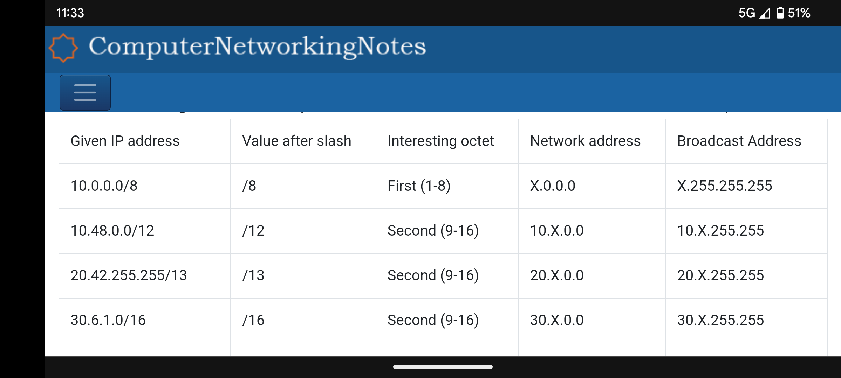

1. If we only have one router and we need to split the IP address pool into 4 different Vlans.

We will need to configure each vlan so that they can communicate with each other.

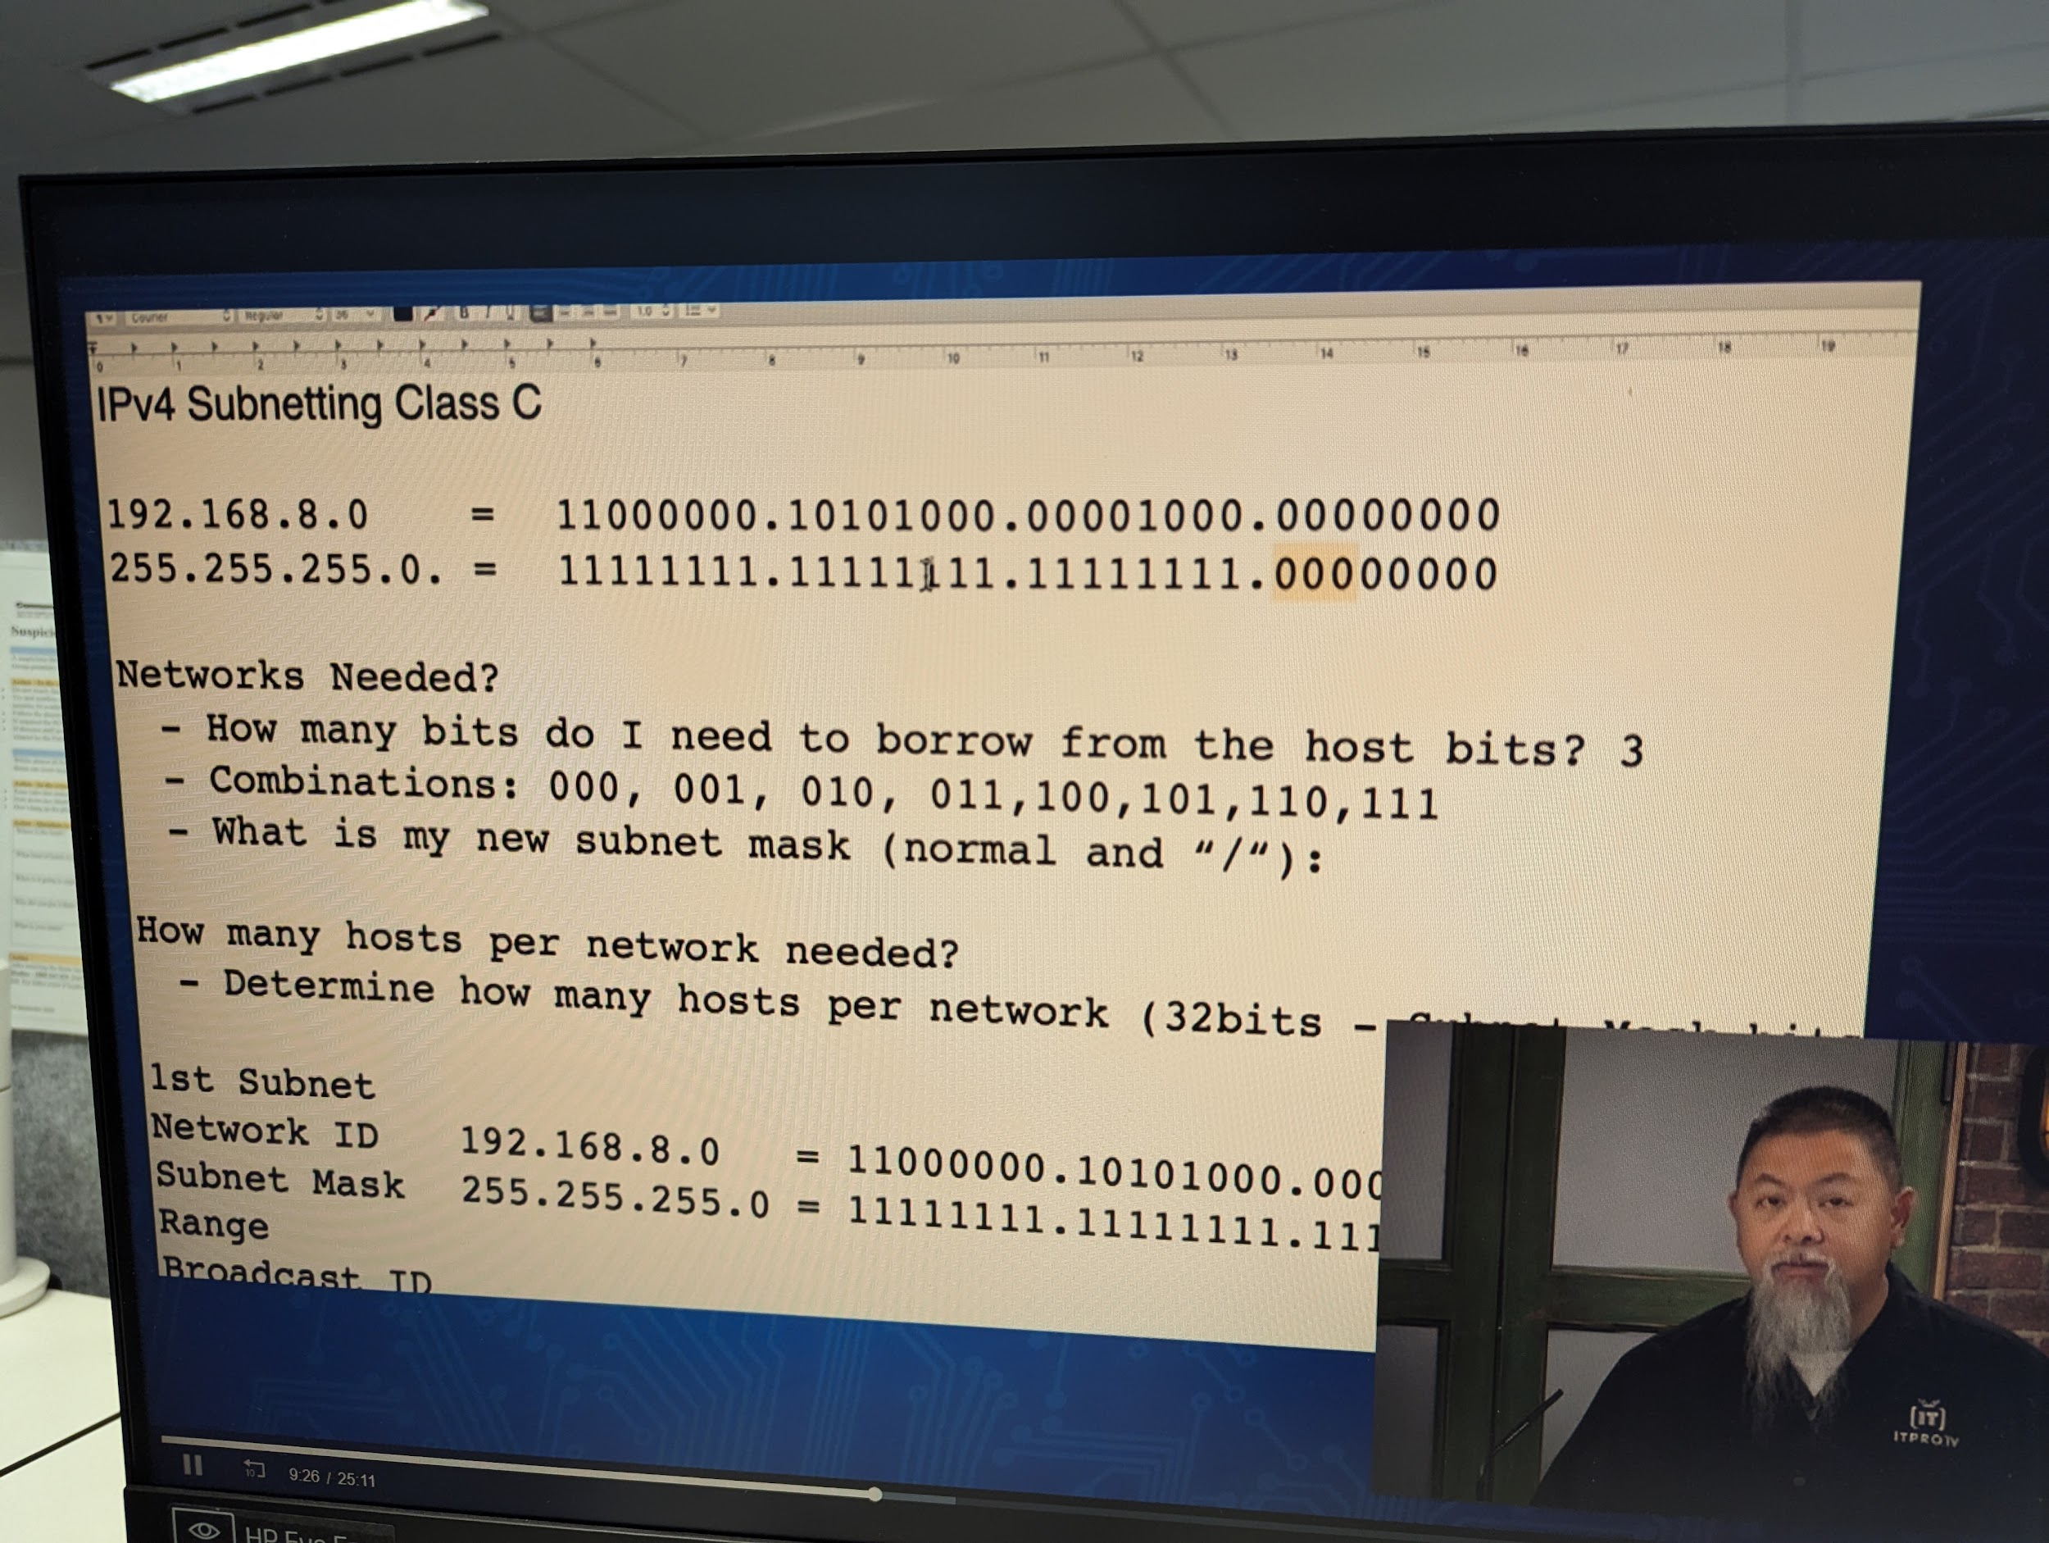

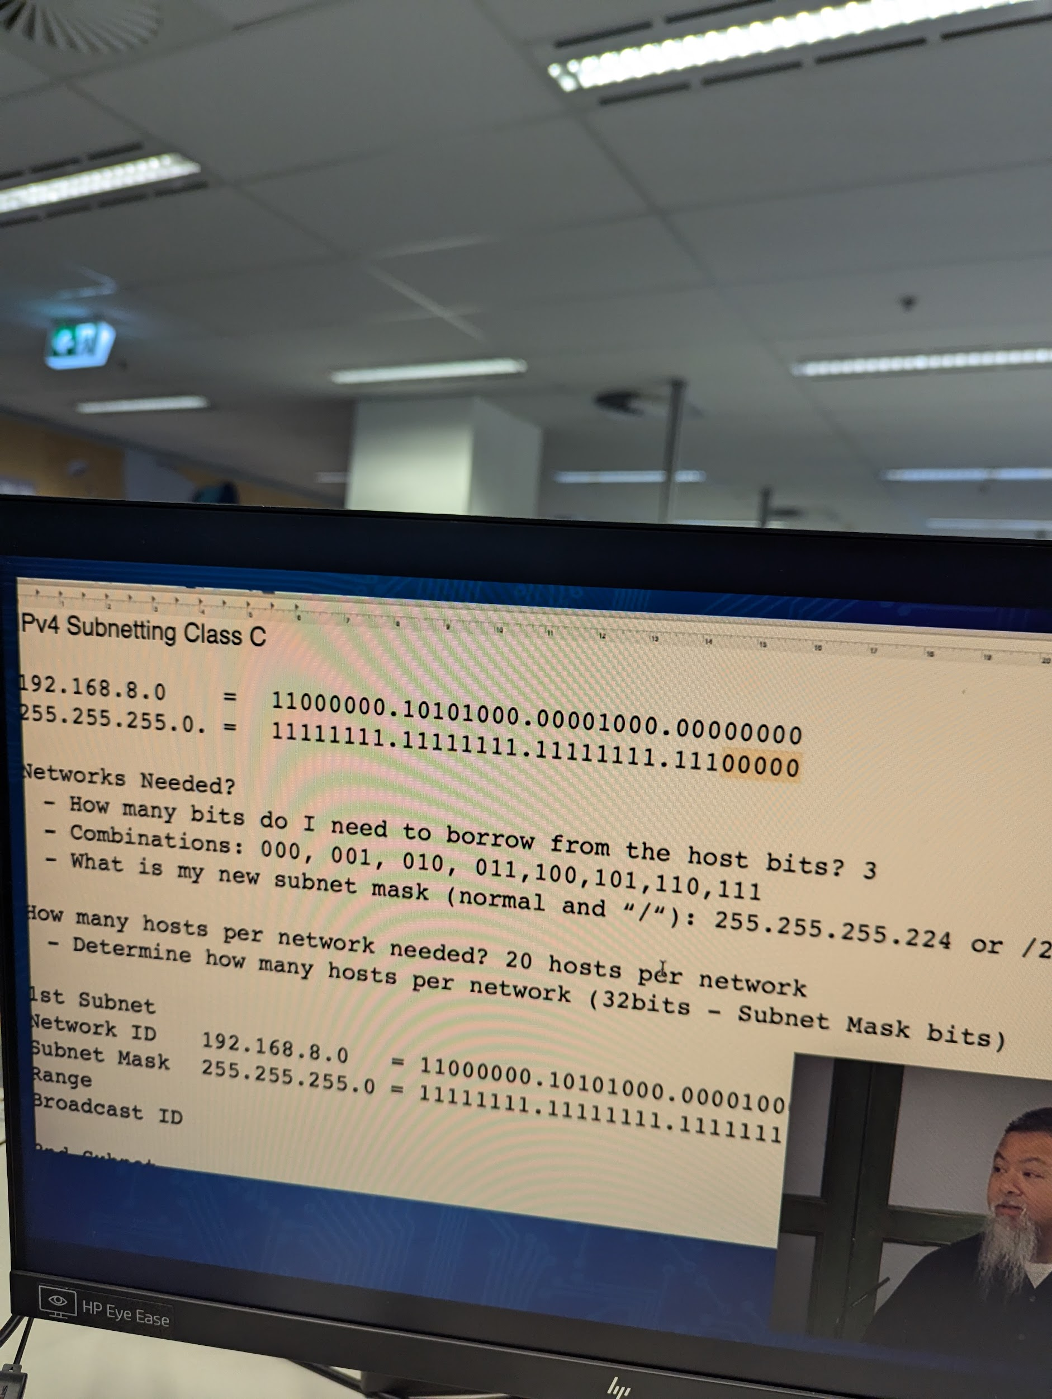

Now we know we have 32 IP ADDRESSES 2^5

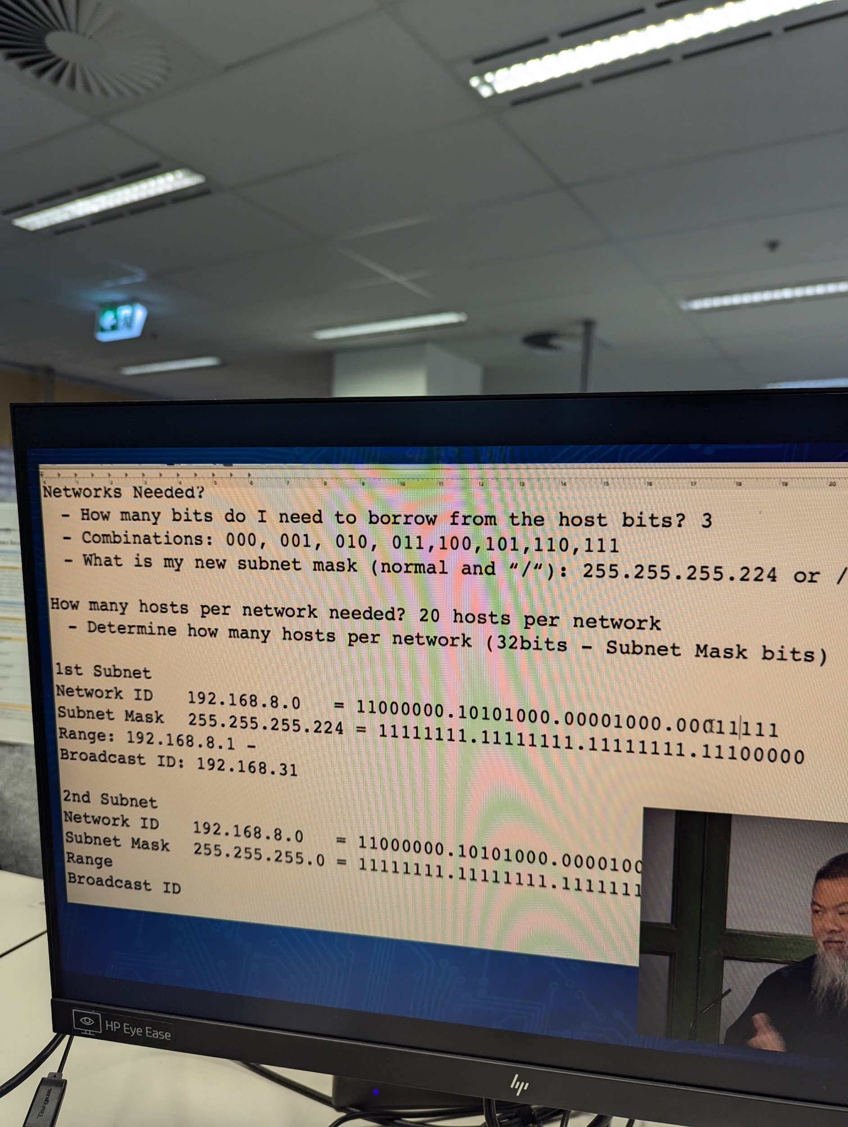

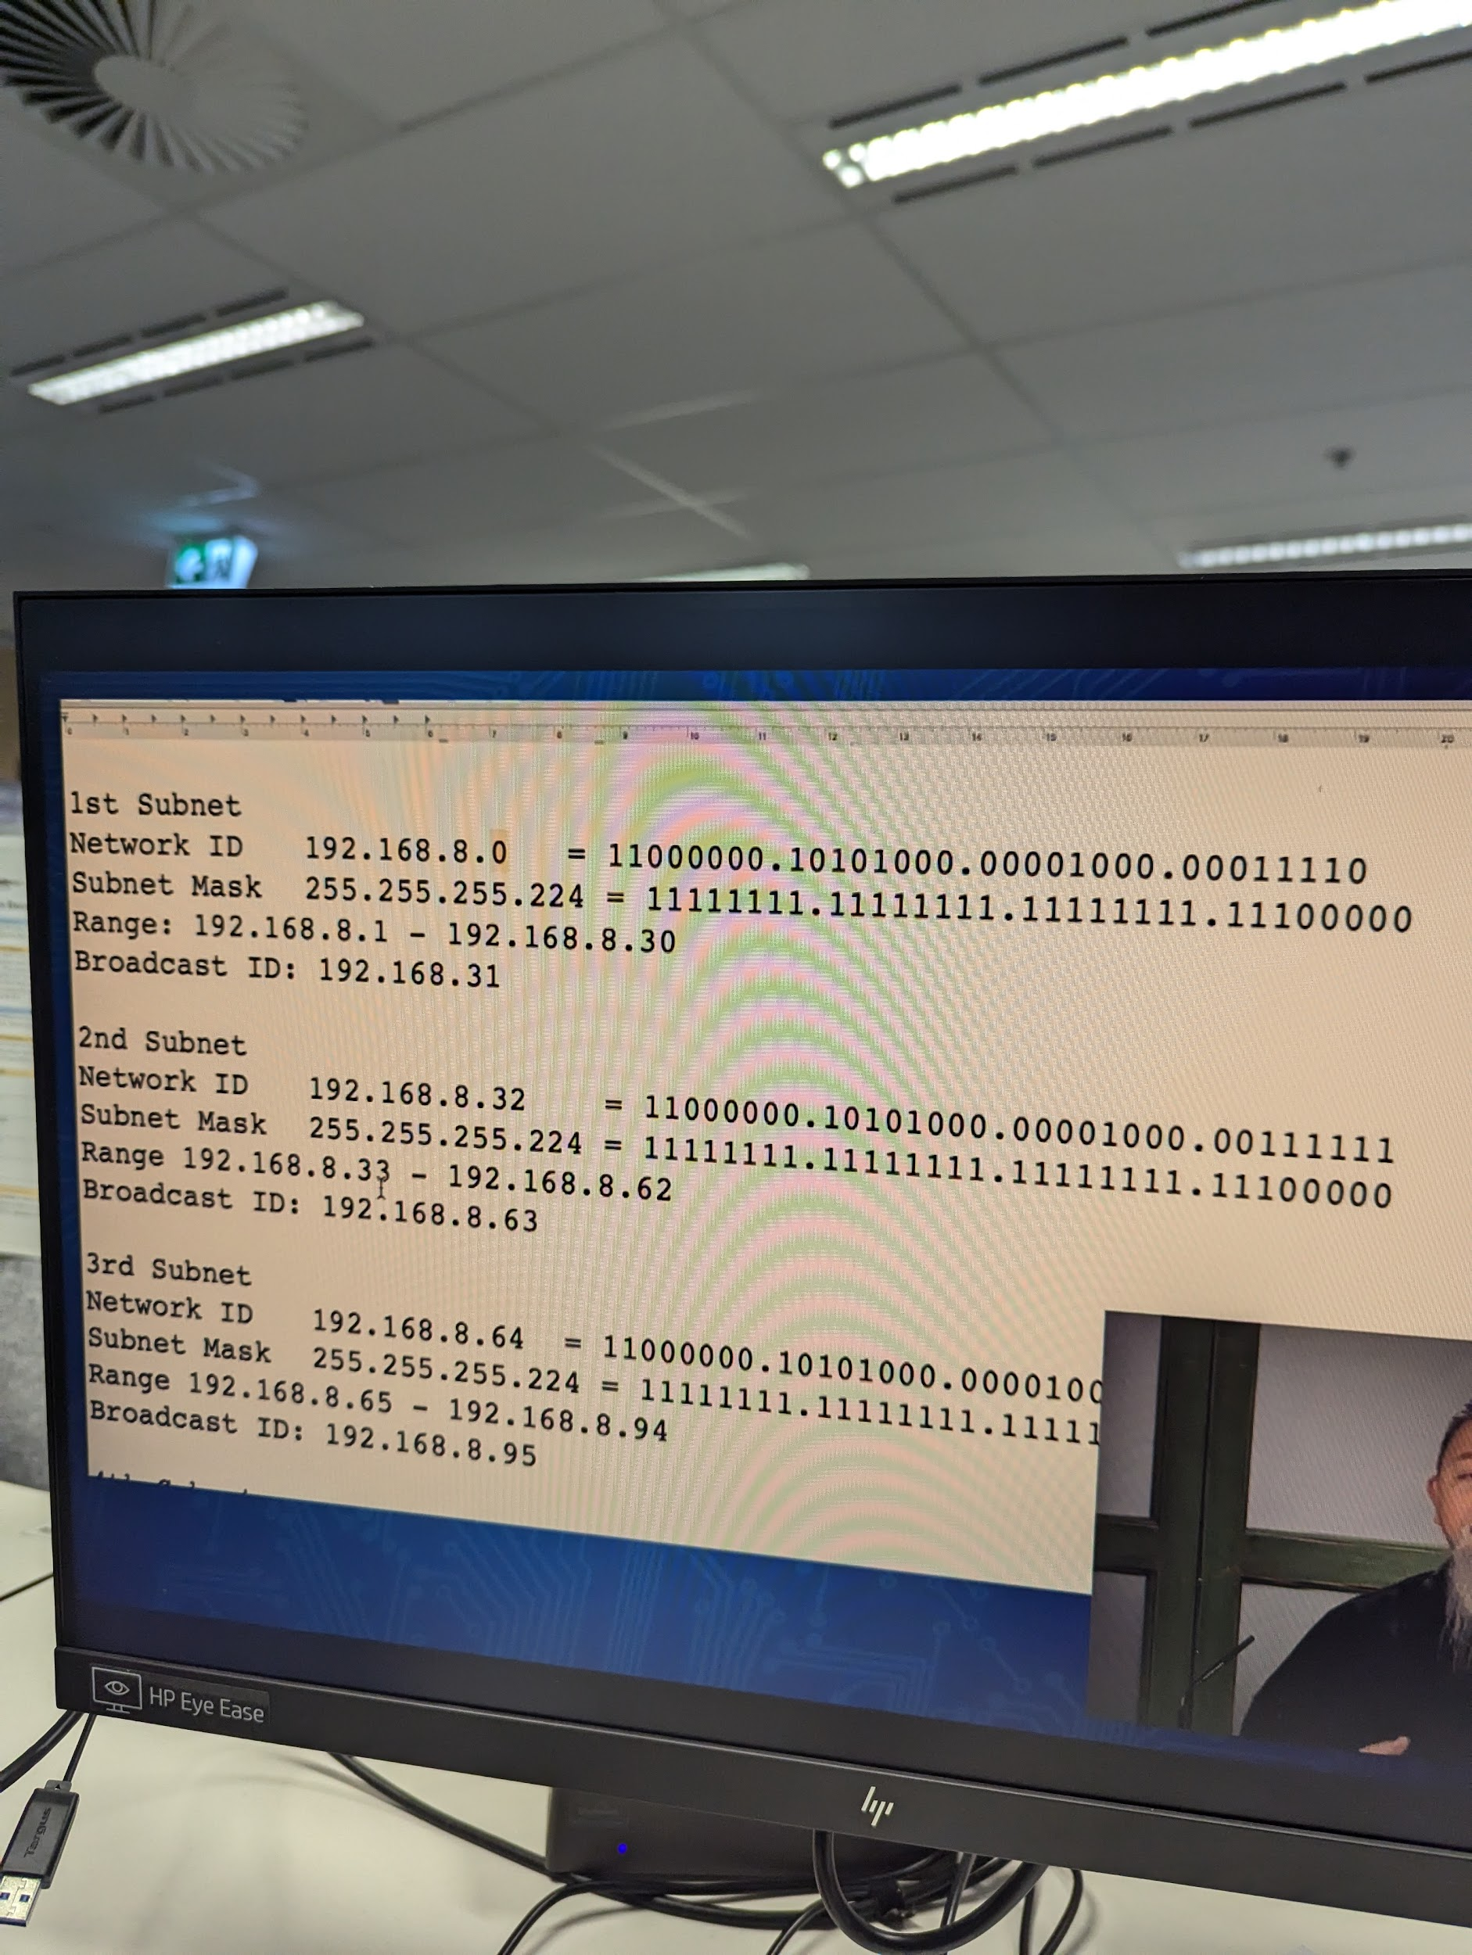

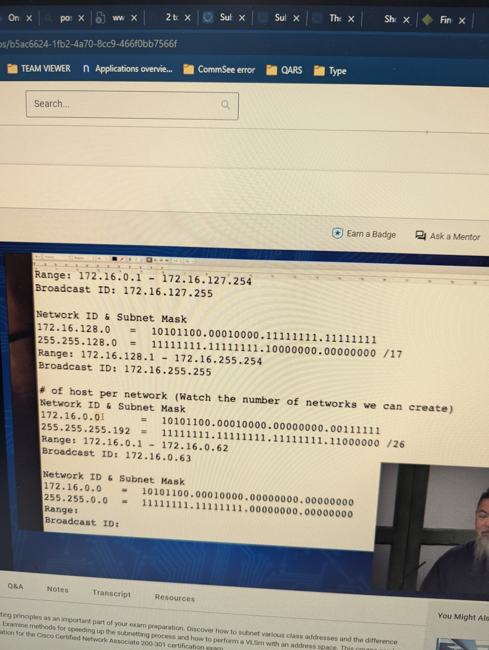

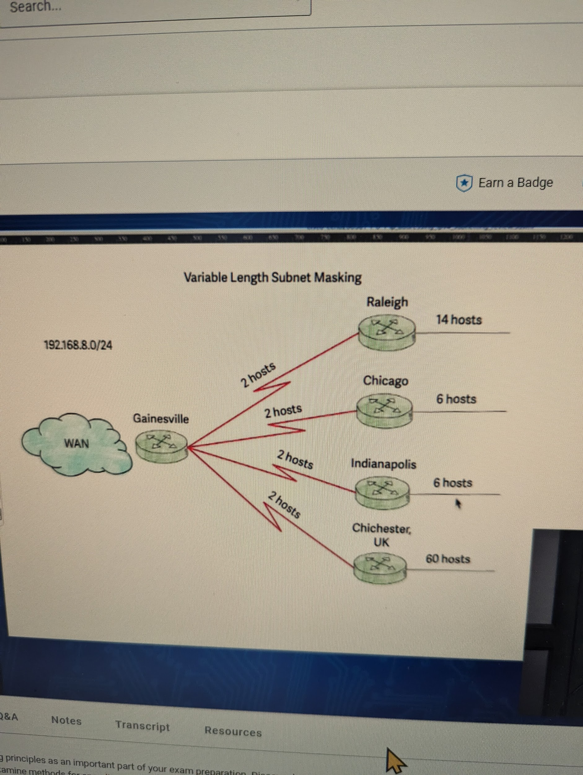

Variable length subnet mask

Class c has maximum of 254 hosts

Above hosts required are less than 254 then we can do it.

Now we cater to the biggest host which has 60 hosts which means the next one we can go to is 64

192.168.8.0/26

The subnet 192.168.8.0/26 actually has 62 usable hosts, not 64.

Here's the calculation:

The /26 subnet mask means that 26 bits are used for the network portion, leaving 6 bits for the host portion (32 - 26 = 6).

With 6 bits for the host portion, you can have 2^6 = 64 possible host addresses.

However, two of these addresses are reserved:

The first address (192.168.8.0) is the network address (or subnet address).

The last address (192.168.8.63) is the broadcast address.

Therefore, the number of usable hosts is 64 - 2 = 62.

Now because the first subnet is 192.168.8.0/26 second subnet has to start with 192.168.8.64.

EXPLANATION:

Since the first subnet 192.168.8.0/26 uses the address range 192.168.8.0 to 192.168.8.63, the next available address for the second subnet would be 192.168.8.64.

So, the second subnet would be 192.168.8.64/26, which would use the address range 192.168.8.64 to 192.168.8.127.

Here's a summary of the subnets:

Subnet 1: 192.168.8.0/26 (192.168.8.1 - 192.168.8.62)

Subnet 2: 192.168.8.64/26 (192.168.8.65 - 192.168.8.126)

Now to cater to Raleigh we need to supply it 16 hosts.

2^4

So we will take 4 bits away

255.255.255.11110000

192.168.8.64/28

Now we cater to Chicago

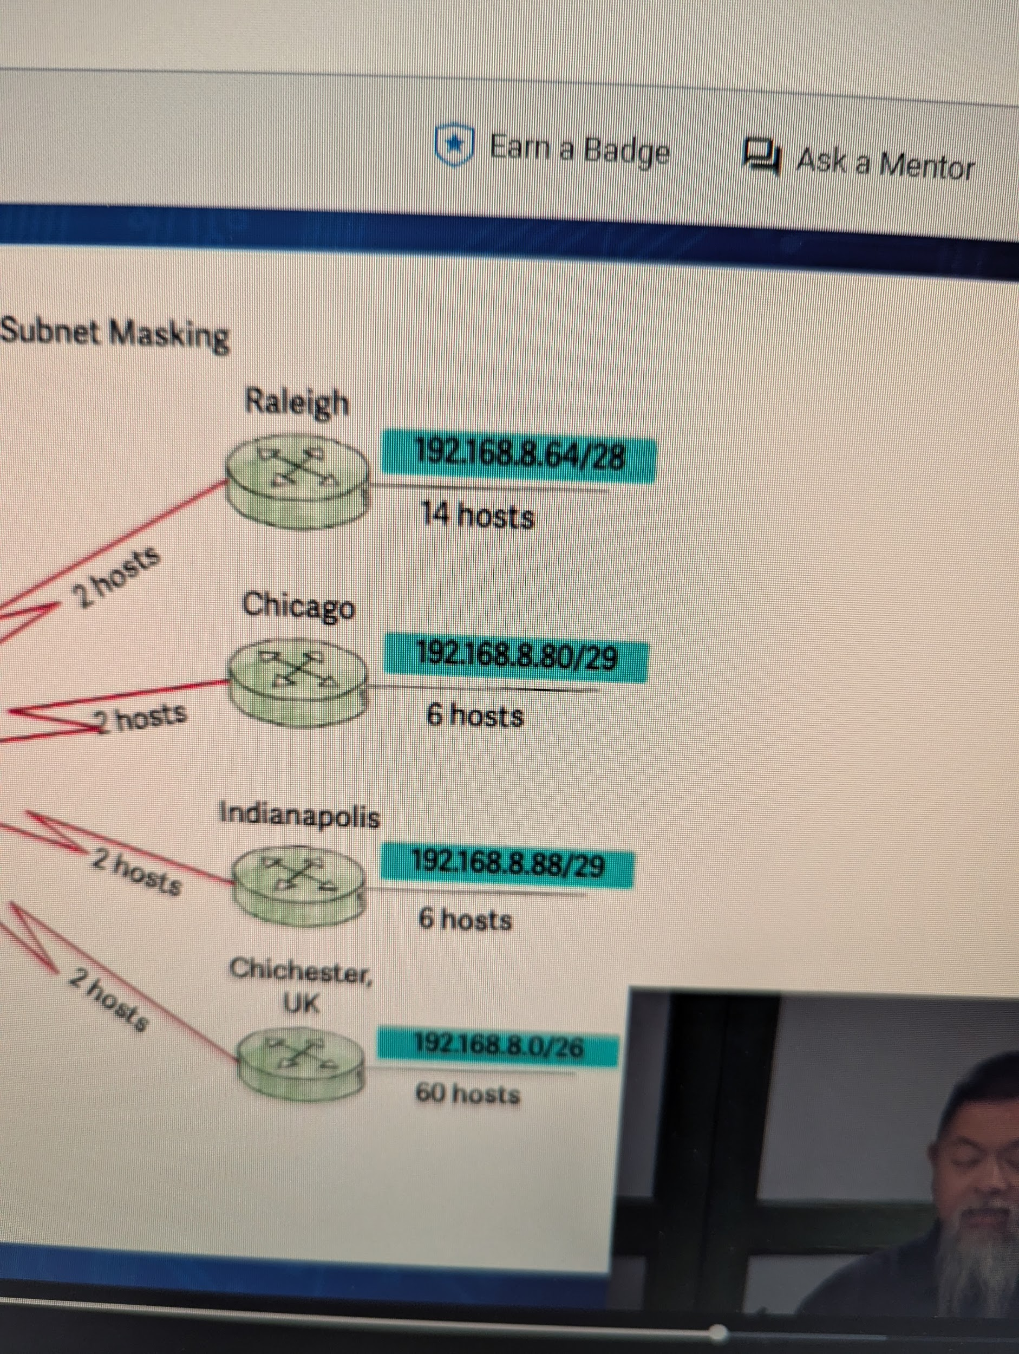

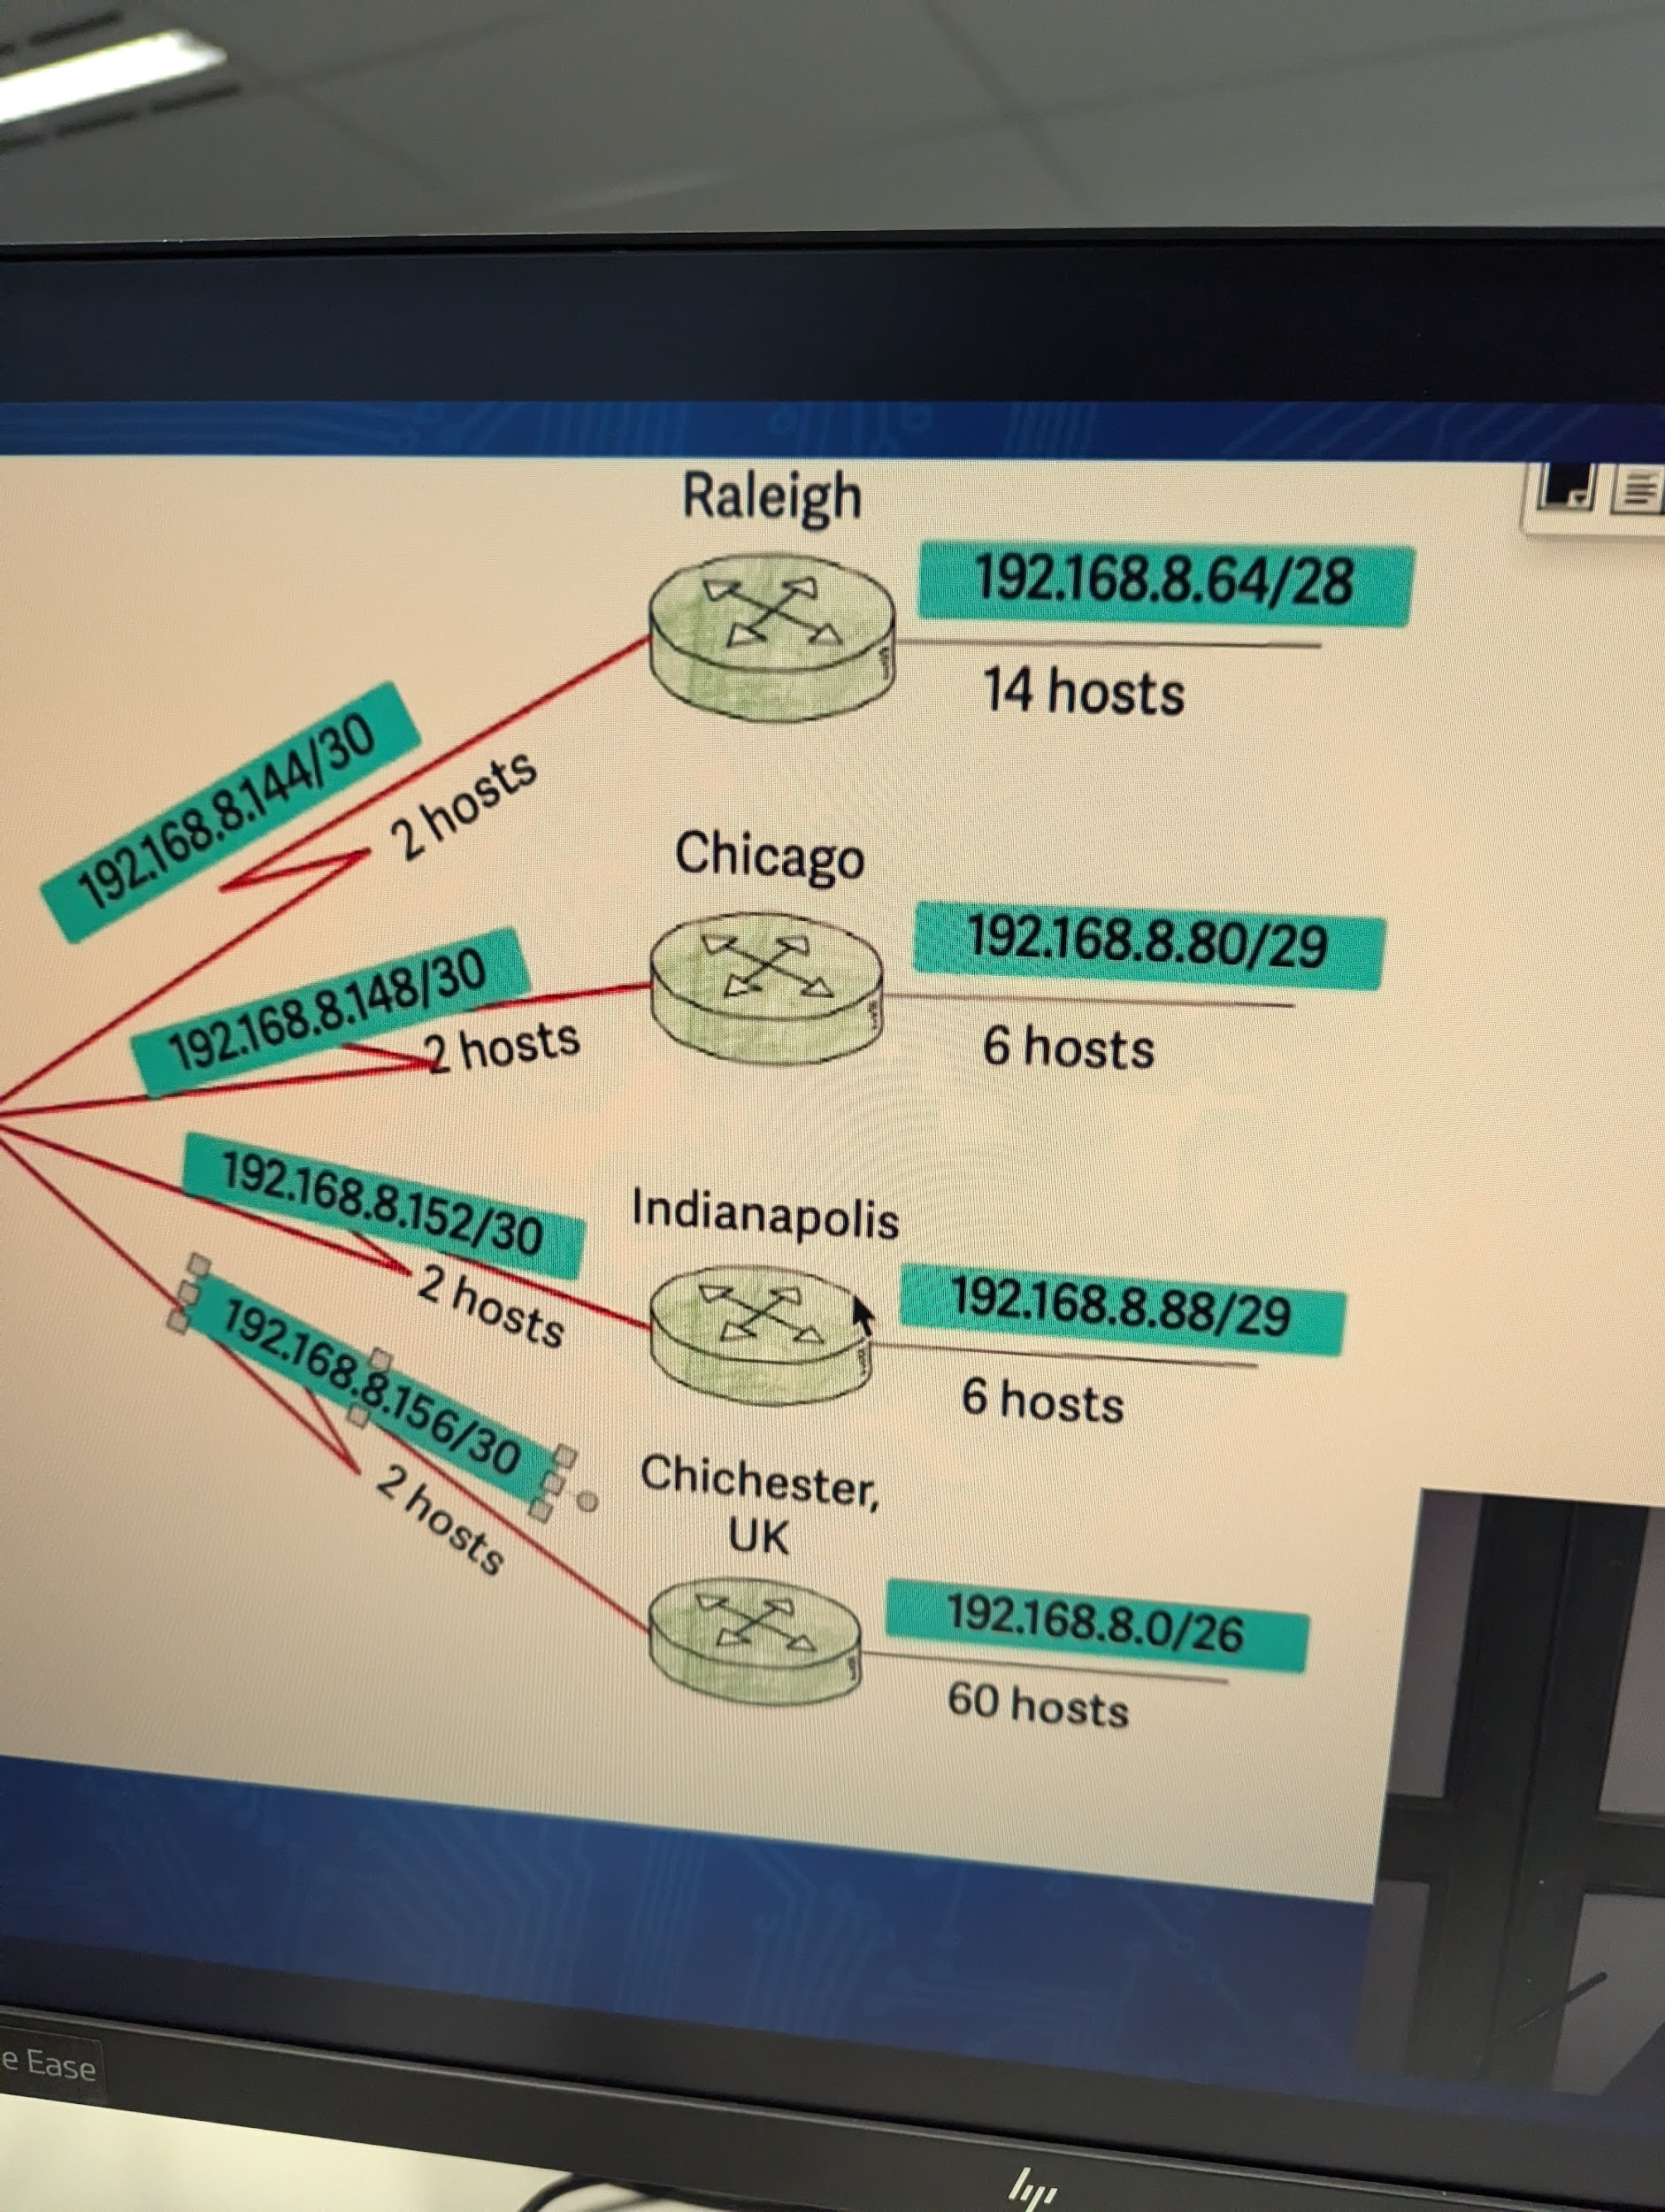

1. nmap -iL list.txt

Make sure that the target list is separated by space or tabs

1. nmap -iR 3

This command tells NMAP to scan any 3 random hosts from the Internet.

1. nmap 192.168.1.0/24 –exclude 192.168.1.1-100

In above example 256 addresses are specified but 1-100 are advised to be skipped.

1. nmap 192.168.1.0/24 –excludefile list.txt
2. Nmap -A 10.10.4.31
3. Scanning an ipv6 address

Nmap -6[target]

1. Before scanning a target NMAP will send ICMP echo request to see if the host is alive first. This can save time and some of the firewall block ICMP packets.

| -Pn | Don't ping  Nmap by default pings the hosts, this feature disables it.  This is useful when scanning systems that are protected by a firewall that blocks ping probes. |
| --- | --- |
| -sn | Perform a ping scan only |
| -PS | TCP SYN PING |
| -PA | TCP ACK PING |
| -PU | UDP PING |
| -PE | ICMP ECHO PING |
| -PP | ICMP TIMESTAMP PING |
| -PM | ICMP ADDRESS MASK PING |
| -PO | IP PROTOCOL PING |
| -PR | ARP PING |
| –traceroute | Trace route |
| -n | Disable reverse DNS resolution |

| –system-dns | Alternate DNS lookup |
| --- | --- |
| –dns-servers | Manually specify DNS servers |
| -sL | Create a host list |